Tools and Technologies — Simple Explanations
A short, plain-English explanation of each tool.

JIRA
Jira is a tool teams use to track work like tasks, bugs, and new features. Each piece of work becomes a ticket that moves through stages such as To Do, In Progress, and Done. It lets everyone see who is working on what and how the project is going.
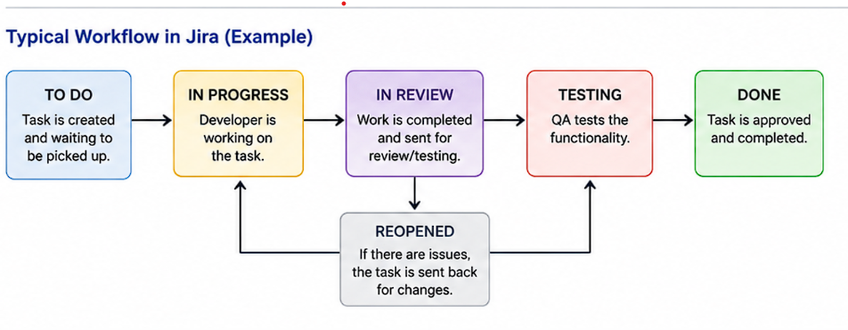

Confluence
Confluence is a place where a team writes and stores its documents and notes online. People use it for things like meeting notes, how-to guides, and project plans, all in one searchable spot. It connects to Jira, so documentation and tickets sit close together.

Visio
Visio is a Microsoft tool for drawing diagrams such as flowcharts, network maps, and org charts. You drag ready-made shapes onto a page and join them with lines to show how things connect. It is mostly used to explain a process or a system in a picture instead of words.

Customer
↓
Web Browser
↓
Frontend
↓
Backend
↙ ↘
Database Payment API

Draw.io
Draw.io (also called diagrams.net) is a free tool for making flowcharts and diagrams in your browser. It does much the same job as Visio but costs nothing and saves straight to Google Drive, OneDrive, or your computer. It is a common choice for quick architecture and process diagrams.
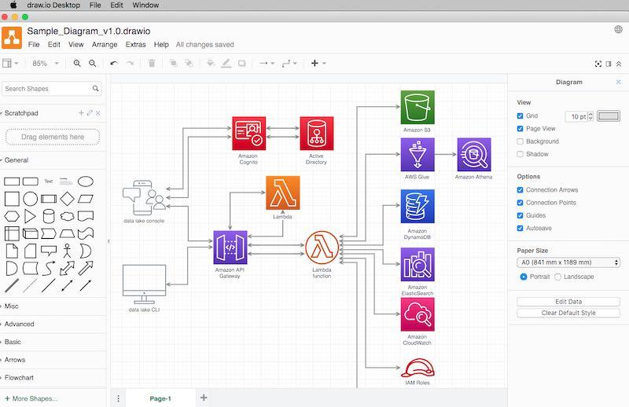

Trello
Trello is a simple task board made of cards you drag between columns. Each card is one task, and the columns usually show its stage, like To Do, Doing, and Done. It suits small teams and personal projects where a full tool like Jira would be too much.

Microsoft Planner
Planner is Microsoft's version of a task board, built into Microsoft 365. You create tasks, put them into buckets, assign them to people, and set due dates. Because it sits inside Teams and Outlook, it works well for teams already using Microsoft tools.

OneNote
OneNote is a digital notebook where you can type notes, paste images, and add checklists. Notes are organised into notebooks, sections, and pages, so they are easy to find later. Everything syncs across your devices and can be shared with others.

Microsoft Office Suite
The Microsoft Office suite is the bundle of everyday work apps: Word, Excel, PowerPoint, Outlook, and more. Word is for documents, Excel for spreadsheets, and PowerPoint for slides. Most workplaces use it as the standard set of tools for writing, reporting, and presenting.

Outlook
Outlook is Microsoft's email and calendar program. You use it to send and receive email, book meetings, and see when people are free. It also holds your contacts and tasks in the same place.

Teams
Teams is Microsoft's app for chat, calls, and online meetings at work. You can message people directly, chat in channels for a project, and share your screen during a meeting. Files, Planner boards, and other Microsoft tools can be added inside it.

Git
Git is a system that keeps track of every change made to a set of files, usually code. It saves snapshots of your work so you can go back to an earlier version if something breaks. It also lets several people work on the same project without overwriting each other.

GitHub
GitHub is a website that stores Git projects online so teams can share and work on them together. It adds features on top of Git, like pull requests for reviewing changes and issues for tracking bugs. It also runs automated build and test jobs through GitHub Actions.

Bitbucket
Bitbucket is another website for hosting Git projects, made by Atlassian. It does much the same job as GitHub but links tightly with Jira and Confluence. Many companies pick it because their other Atlassian tools are already in place.

SharePoint & OneDrive
OneDrive is your personal cloud storage for work files, while SharePoint is shared storage for whole teams and departments. Both keep files online so you can reach them from any device and work on a document with others at the same time. SharePoint also hosts internal sites and pages for sharing news and documents.

Power BI
Power BI is a Microsoft tool that turns raw data into charts and dashboards. It pulls numbers from sources like Excel files and databases, then shows them as visuals you can filter and click through. It helps people spot trends and make decisions without reading through spreadsheets.

Lucidchart
Lucidchart is an online tool for drawing diagrams such as flowcharts, wireframes, and system maps. Several people can edit the same diagram at once in the browser, which makes it good for group work. It is similar to Visio and Draw.io but built around live collaboration.

Microsoft Forms
Microsoft Forms lets you build simple surveys, quizzes, and sign-up forms. You share a link, people fill it in, and the answers are collected automatically. Results appear as instant charts and can be exported to Excel for deeper analysis.

Excel
Excel is a spreadsheet program for storing and working with data in rows and columns. Formulas do the calculations for you, and features like pivot tables and charts help you summarise large amounts of information. It is widely used for budgets, tracking, reporting, and quick analysis.

Notepad++
Notepad++ is a free text editor for Windows that is much more capable than the built-in Notepad. It colours code so it is easier to read, and it can search and replace across many files at once. Developers often use it for quick edits to scripts, config files, and logs.

PowerShell
PowerShell is a Microsoft command-line tool and scripting language for controlling Windows and cloud services. Instead of clicking through menus, you type commands or write scripts to do the job. It is mainly used to automate repetitive admin work such as managing users, files, and servers.

Batch Script
A batch script is a plain text file of Windows commands saved with a .bat extension. When you run it, Windows carries out the commands one after another. It is an older and simpler way to automate small tasks like copying files, backups, or starting programs.

